

DESIGN AND IMPLEMENTATION OF A DUAL-STATE AUTONOMOUS MOBILE SHOPPING ASSISTANT ROBOT PROTOTYPE

A PROPOSAL

BY
KESHINRO MUS’AB MOYOSORE
U19MN1026

SUPERVISOR: DR. A.A IBRAHIM

PROGRAMME: MECHATRONICS ENGINEERING

DEPARTMENT: MECHANICAL ENGINEERING DEPARTMENT

AHMADU BELLO UNIVERSITY ZARIA

MARCH, 2026

INTRODUCTION OF PROJECT

1.1 BACKGROUND AND CONTEXT
The global retail and commercial landscape had experienced a profound paradigm shift over the past two decades, driven extensively by rapid advancements in artificial intelligence, embedded systems, and service robotics (Shashikant Kalsha, 2025). Historically, the physical act of grocery shopping required consumers to manually navigate expansive, often confusing store layouts while physically managing heavy shopping carts. This traditional retail paradigm presented a myriad of challenges. For the elderly, physically impaired, or encumbered shoppers, manoeuvring a heavily loaded cart through crowded aisles induced significant physical fatigue. Furthermore, the sheer scale of modern hypermarkets frequently led to navigational confusion, resulting in frustrated consumers abandoning their intended purchases, which directly impacted retail profitability and customer loyalty (De Simone et al., n.d.).
To remain competitive against the meteoric rise of e-commerce platforms that offered friction-free digital experiences, brick-and-mortar retailers recognized the urgent need to innovate (Welcome to Zscaler Directory Authentication, 2026). The integration of robotic automation emerged as a compelling solution to bridge the gap between physical retail and digital convenience (Renno, 2024). Initially, service robots were confined to highly structured industrial settings, executing repetitive tasks such as sorting, packaging, and heavy material transport. Over time, however, these systems transitioned into dynamic public spaces. Autonomous Mobile Robots (AMRs) revolutionized warehouse logistics by automating order fulfilment, demonstrating their capacity to navigate spaces safely without human intervention (Keith & La, 2024). Yet, transitioning these robotic systems from the highly predictable environment of a closed warehouse to the chaotic, unstructured environment of a customer-facing supermarket presented a formidable engineering challenge. Robots deployed in active retail environments required advanced visual perception to safely navigate around unpredictable human shoppers, sophisticated mapping systems to understand complex store planograms, and highly intuitive interfaces to ensure user acceptance (Oitzman, 2022).
In the context of developing economies, such as Nigeria, the adoption of service robotics remained in its nascent stages. Nigerian supermarkets, retail malls, and departmental stores, particularly in dense urban centers, routinely faced issues related to severe overcrowding, infrastructural bottlenecks, and highly variable customer service experiences. Observational studies in the Nigerian hospitality and service sectors indicated that consumer dissatisfaction frequently arose from core operational inadequacies, excessive queuing, and a systemic lack of service automation. Furthermore, the global health crises catalyzed by the COVID-19 pandemic permanently altered consumer psychology, creating an unprecedented demand for contactless service delivery and automated, hygienic assistance across all public-facing sectors.
To address these compounding retail and demographic challenges, this project was conceptualized to design, fabricate, and implement an autonomous mobile shopping assistant robot tailored specifically for supermarket environments. The proposed robotic system was envisioned as a multi-modal companion capable of fundamentally altering the customer journey through a highly specific operational workflow.
The operational sequence was designed to be seamless and intuitive. A shopper entering the supermarket would initiate interaction by acquiring the robot from its designated home docking station at the store's entrance. Utilizing deep learning-based computer vision systems, the robot would optically lock onto the user's specific profile and continuously follow them at a safe distance throughout the store, serving as an automated, hands-free load carrier. For the scope of this prototype, the chassis and payload capacity were scaled down to handle smaller loads, prioritizing the demonstration of the software architecture and kinematic control over industrial-scale load bearing.
Crucially, the system was engineered to exceed the capabilities of a passive follower. Recognizing that shoppers frequently struggled to locate specific items within expansive aisles, the robot incorporated a dual-state functionality. Should the user require navigational assistance, they could interact with the robot to switch its operational state. The robot would transition from a "follow-me" companion to a "guide-me" leader, utilizing Simultaneous Localization and Mapping (SLAM) and dynamic path planning to physically lead the customer to the exact location of the requested item (Choi et al., 2025). Once the destination was reached, the user could switch the system back to the follower state. This dynamic interplay would continue until the user completed their shopping, finalized their payment at the checkout counter, and allowed the robot to follow them to their vehicle or a designated offloading zone.
The final, critical phase of the workflow addressed the logistical management of the robotic fleet. Once the user offloaded their goods and released the robot, the system would initiate an autonomous "return-to-home" algorithm (MITTAL et al., 2026). Without requiring any manual intervention from supermarket staff, the robot would utilize its internal map and dynamic obstacle avoidance algorithms to navigate upstream against shopper traffic, ultimately redocking at its original home position to await the next customer (Chen et al., n.d.).
While commercial retail robots existed globally, they were predominantly engineered for back-end operations such as inventory scanning, out-of-stock detection, or hazard identification (e.g., Simbe Robotics' Tally or Badger Technologies' Marty), rather than providing direct, personalized customer companionship (De Simone et al., n.d.). Furthermore, commercial AMRs relied on highly expensive, proprietary hardware ecosystems, often utilizing premium 3D LiDARs costing upwards of $12,000 which rendered them economically prohibitive for widespread deployment in developing regions. Consequently, this project was situated as a vital academic prototype. It aimed to demonstrate that sophisticated, dual-state autonomous assistance could be achieved using accessible, budget-conscious embedded systems. By leveraging the open-source Robot Operating System 2 (ROS 2), a differential-drive kinematic base, 2D LiDAR mapping, and monocular vision optimized on a Raspberry Pi microcontroller, the project sought to deliver a highly functional, cost-optimized solution tailored to the operational realities of the Nigerian academic and commercial environment (Odland, 2025).

1.2 RESEARCH QUESTIONS
To guide the development of this prototype, the following specific questions will be investigated:
- How can we optimize lightweight AI vision models (like MobileNet-SSD or YOLO) on a Raspberry Pi so the robot reliably follows a shopper without getting confused by crowds or obstacles?
- How effectively does combining a 2D LiDAR sensor with the ROS 2 navigation stack help the robot map the store and dodge moving carts compared to older, rigid navigation methods?
- What are the cost and performance trade-offs between using a LiDAR versus a depth camera for a budget-friendly student prototype?
- How can we program a reliable "return-to-home" feature so the robot safely navigates back to its base after the customer finishes shopping?
- How does smoothly switching between "follow-me" and "guide-me" modes affect the robot's processing speed, battery life, and overall user experience?

OBJECTIVES

1.3.1 AIM
The primary aim of this project is to develop and evaluate a prototype autonomous mobile service robot capable of providing personalized, hands-free assistance to shoppers in a supermarket environment through "follow-me" functionality and indoor wayfinding.

1.3.2 SPECIFIC OBJECTIVES
To comprehensively realize the overarching main objective, the project will execute the following specific sub-objectives:
- To design an autonomous shopping system for both follow and lead states.
- To build a wheeled robot prototype equipped with a LiDAR sensor.
- To program the robot's navigation using ROS 2 so it can map the supermarket and independently guide customers to specific items.
- To set up an AI vision system that allows the robot to lock onto and follow a specific shopper without getting confused by passing crowds.
- To evaluate the performance of the system in an indoor environment.

JUSTIFICATION AND SIGNIFICANCE
This project is highly significant as it bridges the gap between advanced robotic navigation and everyday consumer utility. For the average shopper, this system promises a seamless, hands-free retail experience, particularly beneficial for the elderly or physically impaired. From a research standpoint, this prototype serves as a practical deployment of ROS 2 and computer vision in a highly dynamic, human-populated environment. By keeping the design within a feasible student budget while retaining high-end functional logic, it demonstrates that complex autonomous behaviours (like switching between visual tracking and SLAM-based wayfinding) can be achieved efficiently.

SCOPE AND LIMITATIONS
This project is strictly a prototype designed to demonstrate proof-of-concept. The robot's payload capacity will be limited to small, lightweight items representing a typical shopping basket, rather than a full-scale heavy-duty shopping cart. The testing environment will be a controlled indoor flat-terrain setting mimicking a supermarket aisle. The vision system's target locking relies on adequate lighting conditions, and extreme crowds may induce temporary tracking occlusions, which the system will attempt to mitigate through predictive tracking logic.

LITERATURE REVIEW

2.1 REVIEW OF RELEVANT THEORIES AND CONCEPTS

2.1.1 Human-Robot Interaction (HRI) and Technology Acceptance Theories
Getting people to actually use a robot assistant instead of a traditional shopping cart relies heavily on human psychology. This project will rely on the Technology Acceptance Model (TAM), introduced by Davis (1989), which simply states that people will only use a new piece of technology if it is genuinely helpful and effortless to operate. If the robot constantly loses track of its user, it becomes a burden rather than a help. Furthermore, the Diffusion of Innovations (DOI) theory by Rogers (2003) explains that making the robot's benefits highly visible in the store will accelerate its acceptance among shoppers. Recent studies also highlight "speciesism" (a psychological bias where humans inherently feel superior to machines) which can actively influence whether a shopper feels comfortable interacting with an intelligent retail robot (Carlos et al., 2023).

2.1.2 Simultaneous Localization and Mapping (SLAM) Concepts
For a robot to guide a shopper to a specific aisle, it must know what the store looks like and where it currently stands. This process is called SLAM. Instead of using basic sensors, robots are usually equipped with LiDAR, which acts like a spinning laser eye to measure distances and build a highly accurate map of the environment. To process this laser data, the slam toolbox is utilized, which is the premier open-source mapping library within the ROS 2 framework. It was explicitly created to map large, dynamic spaces (like a busy supermarket) in real-time without computational lagging (Macenski & Jambrecic, 2021).

2.1.3 Vision-Based Object Tracking and Deep Learning Architectures
The robot's "follow-me" feature relies entirely on artificial intelligence acting as its vision. Standard computer vision methods fail when a supermarket gets crowded. Therefore, deep learning object detection models are used. While architectures like YOLO (You Only Look Once) are famous for extremely fast, real-time object detection, models like MobileNet-SSD. MobileNet-SSD is mathematically engineered to run efficiently on low-power, budget-friendly microcontrollers (like the Raspberry Pi) without causing the system to overheat or crash. However, just detecting a "person" isn't enough in a crowded store. To solve this, a visual Re-Identification (Re-ID) algorithm is usually integrated. This allows the robot to learn the specific colors and patterns of the user's clothing, ensuring that if a stranger walks between them, the robot won't get confused and follow the wrong person (Rollo et al., 2023).

2.1.4 Autonomous Navigation Stacks and Dynamic Obstacle Avoidance
The robot must safely get from point A to point B without crashing into moving shopping carts. To achieve this, the ROS 2 Navigation Stack, commonly known as Nav2, which acts as a production-grade GPS for the robot is commonly used. Nav2 calculates the shortest path to an item or back to the home dock. To actively dodge unexpected obstacles, Dynamic Window Approach (DWA) algorithm must be implemented. DWA constantly evaluates the immediate space around the robot and adjusts its speed and steering on the fly, allowing it to weave smoothly and safely through foot traffic (Wei et al., 2025).

ANALYSIS OF EXISTING RESEARCH AND STUDIES
A substantial and continually expanding body of academic literature had explored the deployment of autonomous systems within retail, public, and hospitality spaces. The historical trajectory of this research demonstrated a clear, methodological evolution from simple, track-bound automated guided vehicles (AGVs) to highly complex, perception-driven autonomous mobile robots (AMRs).

2.2.1 Early Indoor Navigation and Foundational Service Robotics
Early research focused on getting robots to move safely indoors. For example, Acosta et al. (2006) built a service robot designed to navigate a controlled room to collect dishes. While successful, it relied on a strictly rigid environment and lacked human interaction. Similarly, Thanh (2019) tested robots that followed rigid lines on the floor, noting that while they worked well in simple setups, they struggled the moment an unexpected obstacle appeared. This proved that dynamic spaces like supermarkets need much smarter, perception-based navigation rather than rigid path-following.

2.2.2 Advancements in Shopping Assistant Robots
More recent studies have tackled the chaos of retail stores. Thompson et al. (2018) designed "Blueberry," a robot that successfully guided customers to products using contextual clues rather than a pre-built map, receiving highly positive feedback from users. However, it only guided and did not physically carry items. On the inventory side, Simone et al. (2023) developed "ROSCH," a robot utilizing YOLOv6 deep learning to quickly spot empty supermarket shelves. While highly accurate, it was built strictly for store managers, omitting customer interaction. Bridging this gap, Nithya Priya et al. (2021) created an autonomous trolley that followed a digital shopping list, while Dworakowski et al. (2021) introduced ContextSLAM to help robots intelligently explore and find specific products in crowded grocery stores (De Simone et al., n.d.).

2.2.3 Developments in "Follow-Me" Tracking and Vision Integration
Getting a robot to reliably follow a specific person is a major technical hurdle. Linder et al. (2020) successfully deployed a guidance robot in a busy airport by fusing YOLO object detection with 3D depth cameras to keep track of humans in dense crowds. For smaller, budget-friendly robots, researchers often turn to the MobileNet-SSD architecture, originally detailed by Howard et al. (2017), which provides fast and accurate object detection without needing heavy, expensive computers. To solve the issue of a robot losing its user when someone else walks by (visual occlusion), Rollo et al. (2023) combined Re-Identification (Re-ID) technology with collision-free navigation. This allowed the robot to autonomously learn a person's specific clothing features and reliably follow them through busy workplaces without getting confused by strangers (Rollo et al., 2023).

2.2.4 LiDAR vs. Vision for Indoor SLAM
There is an ongoing debate about the best sensors for indoor mapping. While cameras offer rich visual details, 2D LiDAR is often preferred because it isn't blinded by the sudden lighting changes common in retail stores. To make this technology more accessible, Peña Queralta et al. (2020) designed an innovative system that combined multiple low-cost 2D LiDARs to create highly accurate 3D maps, proving that advanced mapping doesn't always require exorbitantly expensive commercial sensors.

2.2.5 Return-to-Home and Autonomous Docking Algorithms
For a robot to be truly useful, it must manage itself after a task is done. Commercial deployments, like the Geek+ AMRs used in supermarket supply chains, have proven that autonomous robots must be able to flexibly move goods and continuously route themselves back to designated charging zones to maintain efficiency (Staff, 2022). Academically, this is achieved using reliable path-planning algorithms, such as Dijkstra's or the A* algorithm. These algorithms calculate the safest and shortest route to steer a robot back to its "home" docking station once a shopping trip is complete, ensuring it avoids moving obstacles along the way (Younes & Barczyk, 2021).

2.3 IDENTIFICATION OF RESEARCH GAPS AND AREAS FOR INVESTIGATION
Despite rapid advancements, significant research gaps remain when synthesizing these technologies into a single retail platform.
- The Absence of Unified, Dual-State Modalities (Follow vs. Guide):
Most robots are rigidly designed to either strictly follow a human or strictly guide them. There is a lack of research on a unified system that seamlessly switches between a passive, load-carrying follower and an active navigational guide upon user command.
- Target Occlusion Vulnerability in High-Density Retail Aisles:
Existing budget-friendly robots often fail catastrophically when their designated user is momentarily obscured. The integration of continuous visual Re-ID with lightweight detection models on resource-constrained hardware requires deeper investigation.
- The "Return-to-Home" Post-Checkout Logistical Gap:
Most literature focuses on the active shopping phase. There is limited open-source framework demonstrating how a robot can seamlessly disengage its vision protocols post-checkout and utilize Nav2 to autonomously navigate upstream against shopper traffic back to a home dock.
This project was explicitly designed to address and fill these identified gaps. By developing an integrated, dual-state (following and guiding) autonomous shopping assistant, the research would push the boundaries of what is achievable on resource-constrained hardware. The system intended to leverage highly optimized MobileNet-SSD architectures combined with Re-ID to solve the target-lock occlusion problem. Furthermore, it explicitly aimed to engineer a dynamic return-to-home loop utilizing the Nav2 stack, ultimately serving as a scalable, highly functional prototype suitable for the operational and economic realities of the Nigerian retail sector.

METHODOLOGY

3.1 DESCRIPTION OF WORKING PRINCIPLES

3.1.1 SOFTWARE AND CONTROL LOGIC
The software framework will be built upon ROS 2, running on a Linux OS.
- Target Locking & Follow-Me: The camera feed will be processed using a lightweight deep learning object detection model (MobileNet-SSD). A tracking algorithm with Re-ID will assign a unique ID to the user. Bounding box coordinates will be translated into velocity commands to keep the user centered in the frame.
- Wayfinding & Navigation: When the user switches the robot to "Guide Mode", the vision tracking pauses. The robot queries the pre-mapped static map of the supermarket using the Nav2 stack. The robot utilizes AMCL to find its position and plans a path, leading the user to the destination.
- Return to Home: Upon successful checkout, the user releases the robot. A pre-saved "Home" coordinate is triggered, and the robot uses the same Nav2 stack to autonomously navigate back to its starting station.

3.1.2 OPERATIONAL STATES (SYSTEM FLOW)
- State 0 (Idle): Robot is docked at the store entrance.
- State 1 (Pairing): User stands in front of the robot; vision system locks onto the user's features.
- State 2 (Follow Mode): User walks; robot computes distance and angle, driving motors to follow while avoiding dynamic obstacles.
- State 3 (Guide Mode): Triggered by user input (via physical switch and buttons). Robot leads user to a specific coordinate. Once reached, reverts to State 2.
- State 4 (Return Home): Triggered post-checkout. Robot path-plans back to home coordinates.

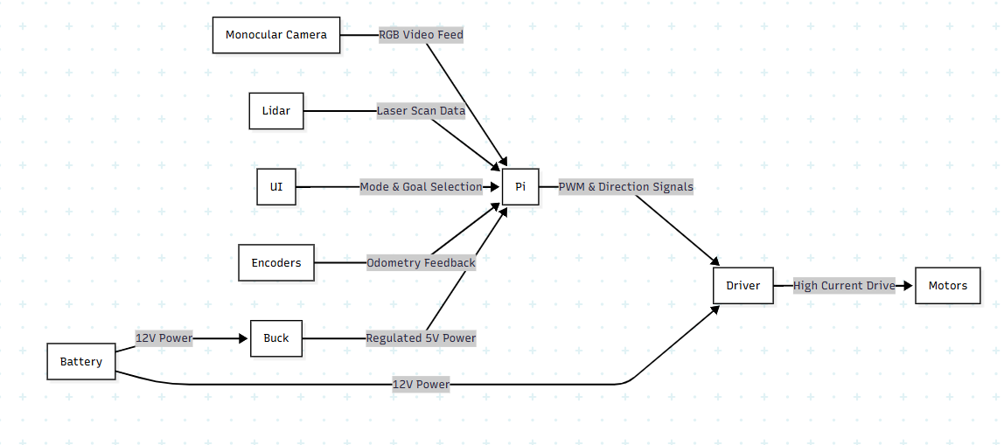
Figure 3.1 Block Diagram of System Architecture

3.2 DESIGN CONSIDERATION
The engineering methodology and hardware selection for this robotic prototype were heavily driven by strict considerations of processing efficiency, mechanical stability, environmental robustness, and intelligent budget optimization.
To keep this prototype efficient, highly functional, and within a realistic student budget, the design choices prioritize intelligent software over expensive, heavy-duty mechanical parts.
- Kinematics and Payload (Movement):
  - Differential-drive chassis will be used (two driven wheels in the centre with passive caster wheels for balance). This allows the robot to spin completely in place (zero-turning radius) to easily navigate tight supermarket corners.
  - Because this is a budget-conscious prototype, heavy-duty mechanical load bearing is not the major focus. The robot is scaled down to carry its own electronic components (Pi, LiDAR, battery) along with very small, light loads of less than 5N taking g=10m/s².
  - A standard 12V DC gear motors equipped with encoders will be used. The encoders act like a pedometer, telling the robot exactly how far it has travelled so it doesn't get lost.
  - A reliable BTS7960 43A motor driver will be used to control the wheels safely without overpowering the microcontroller.
- Computational Architecture and Power Management
  - The Brain: The Raspberry Pi 4 (4GB RAM) was chosen because it offers the perfect balance of low cost and high computing power. It is strong enough to process AI camera feeds and run the ROS 2 navigation maps simultaneously.
  - The Battery: A 12V Lithium-Ion battery pack will power the entire system, offering a lightweight profile with enough charge to keep the robot running through long tests and return-to-home manoeuvres.
- Sensors and Contingency Alternatives (Mapping):
  - Primary Sensor: The robot will map the store using a SLAMTEC RPLidar A1. It spins 360 degrees, shooting lasers to measure distances perfectly, no matter how bright or dark the supermarket aisles get.
  - Budget Alternatives: If a LiDAR cannot be acquired, the system is modular. Viable, low-cost alternatives include:
    - Repurposed Xbox Kinect (V1 or V2): Extremely cheap on the used market and highly effective for indoor 3D depth mapping in student projects.
    - Orbbec Astra: A much more affordable depth camera alternative compared to premium models like the Intel RealSense.
    - Ultrasonic Sensors (HC-SR04): A network of ultra-cheap ultrasonic sensors can be placed around the chassis alongside a standard webcam as a last-resort backup to prevent wall collisions.
- Human Identification and Re-Identification (Vision):
  - The Camera: A simple, low-cost USB webcam or Raspberry Pi Camera Module will act as the robot's eyes.
  - Target Locking: To ensure the robot follows the correct person and not a random passing shopper, it will run a lightweight AI model (MobileNet-SSD) to detect humans.
  - Re-ID: Once a human is detected, the robot will use a Re-Identification (Re-ID) algorithm to extract unique visual features (like the specific color, shape, or pattern of the user's clothing). This acts as a digital fingerprint, ensuring the robot maintains a persistent lock on its assigned owner even in cluttered aisles.
- User Interface (Buttons & Switches):
  - Instead of a fragile and expensive touchscreen, the robot will feature a highly reliable, tactile control panel using physical push buttons and switches.
  - Mode Switch: A physical toggle switch will allow the shopper to instantly flip the robot between the passive "Follow-Me" mode and the active "Guide-Me" mode.
  - Location Buttons: While in guiding mode, the user can press specific push buttons programmed to represent different store aisles (e.g., "Beverages" or "Checkout"), prompting the robot to automatically lead the way.

3.3 DESIGN ANALYSIS / THEORIES
- Deep Learning & Vision Tracking: The robot relies on embedded computer vision to see. MobileNet-SSD detects people, while Re-Identification (Re-ID) extracts unique visual cues (like clothing colors) so the robot stays locked onto its specific owner and isn't distracted by intersecting pedestrians.
- Autonomous Navigation (SLAM): A robot must understand its space to move safely. Simultaneous Localization and Mapping (SLAM) use the LiDAR to draw an internal floor plan, while the ROS 2 Nav2 stack calculates the safest path to travel.
- Kinematic System Control: The Raspberry Pi acts as the central brain. It controls the robot's physical movement by sending Pulse Width Modulation (PWM) signals to the high-power motor drivers, determining exactly how fast each wheel should spin.
- Human-Robot Interaction: Users need instant, reliable feedback to feel comfortable using a machine. Physical push-buttons and switches provide an intuitive, error-free way for customers to interact with the robot in a high-traffic environment.

3.4 DESIGN CALCULATIONS AND MODELLING
- Differential Drive Kinematics: The robot steers by altering the speed of its left and right wheels independently.
  - Linear Velocity (straight speed) is $υ=\frac{Vr+VI}{2}$
  - Angular Velocity (turning speed) is $=\frac{Vr-VI}{L}$ , where L is the distance between the two wheels.
- Power Consumption Estimate:
  - Total system draw is roughly 4A - 5A at 12V.
  - Raspberry Pi 4: ~3A under full computing load (stepped down to 5V).
  - RPLiDAR A1: ~350mA during active scanning.
  - DC Gear Motors: ~400mA per motor during normal load, spiking to ~1.5A during a stall.
- Latency Tolerance:
  - Camera AI Tracking: Must process at least 15 frames per second (approx. $< 60$ms delay) to keep up with a walking human.
  - Obstacle Avoidance: The Nav2 planner needs a response time of $< 500$ms to effectively dodge moving objects.
- Logic Flow: Scan Environment (Vision/LiDAR) → Process Data (Re-ID / Path Plan) → Actuate Motors → Reach Destination → Return Home.

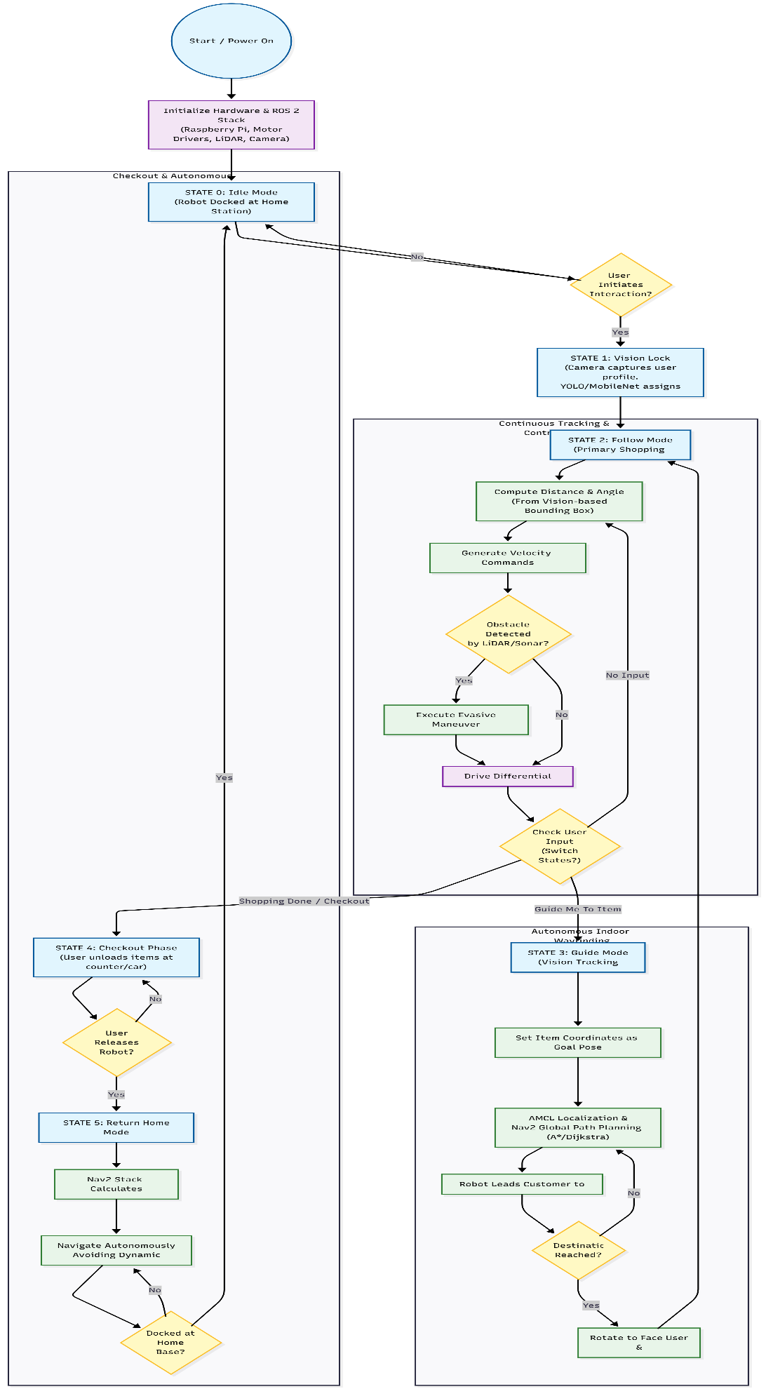
Figure 3.2 Flowchart of the Verification Process

3.5 COMPONENT SELECTION
To ensure the project remains financially viable pending supervisor review, the following primary components will be chosen, alongside proposed ultra-low-cost alternatives:
- Central Brain: The Raspberry Pi 4 (4GB) will be chosen over expensive edge-AI computers (like the Nvidia Jetson Nano) because it offers the best balance of cost and power needed to run ROS 2.
  - Budget Alternative: A repurposed Raspberry Pi 3B+ or Orange Pi can be used to significantly cut costs, though it may slightly reduce the speed of the AI tracking.
- Mapping Sensor: The SLAMTEC RPLidar A1 will be used as the main sensor because its 360-degree laser scanning is the gold standard for reliable indoor mapping.
  - Budget Alternative: A used Xbox Kinect V1/V2 or an Orbbec Astra depth camera provides excellent 3D mapping at a fraction of the cost. If strict budget limits apply, a ring of very cheap HC-SR04 Ultrasonic sensors can be used strictly for obstacle dodging instead of full mapping.
- Vision Camera: A Standard USB Webcam will be selected for the "follow-me" AI tracking. It plugs directly into the Pi and completely avoids the high costs of premium smart cameras (like the OAK-D).
- Drive System: 12V DC Gear Motors with Encoders paired with a BTS7960 Motor Driver will be chosen to provide the torque needed to carry a basket and track wheel movements.
  - Budget Alternative: Because the prototype will only carry very small, light loads (like a smartphone), we can drastically cut costs by using basic DC TT Motors and a cheap L298N Motor Driver, though this makes calculating precise distance harder.
- User Interface: Push buttons and toggle switches will be chosen. They are vastly cheaper, much more durable, and easier to wire than fragile LCD touchscreens.

3.6 CONSTRUCTION/ASSEMBLING (FIRMWARE AND HARDWARE)

3.6.1 Firmware and Software Setup:
- The Raspberry Pi 4 will be programmed using Python and C++ within the ROS 2 (Humble/Iron) framework, running on an Ubuntu operating system.
- Key software packages used will include: slam toolbox (for mapping), Nav2 (for path planning), and TensorFlow Lite/OpenCV (for vision tracking).

3.6.2 Hardware Integration:
- LiDAR and Webcam: Connected directly to the Raspberry Pi 4 via high-speed USB ports.
- Motors and Encoders: Wired to the BTS7960 high-power motor driver and the microcontroller GPIO pins to control speed and read distance data.
- User Interface (Buttons): Wired directly to the digital input GPIO pins on the Raspberry Pi.
- Power Supply: All components will be connected to a 12V Lithium-Ion battery. The motors will draw 12V directly, while a buck converter will step the voltage down to a safe 5V to power the Raspberry Pi.

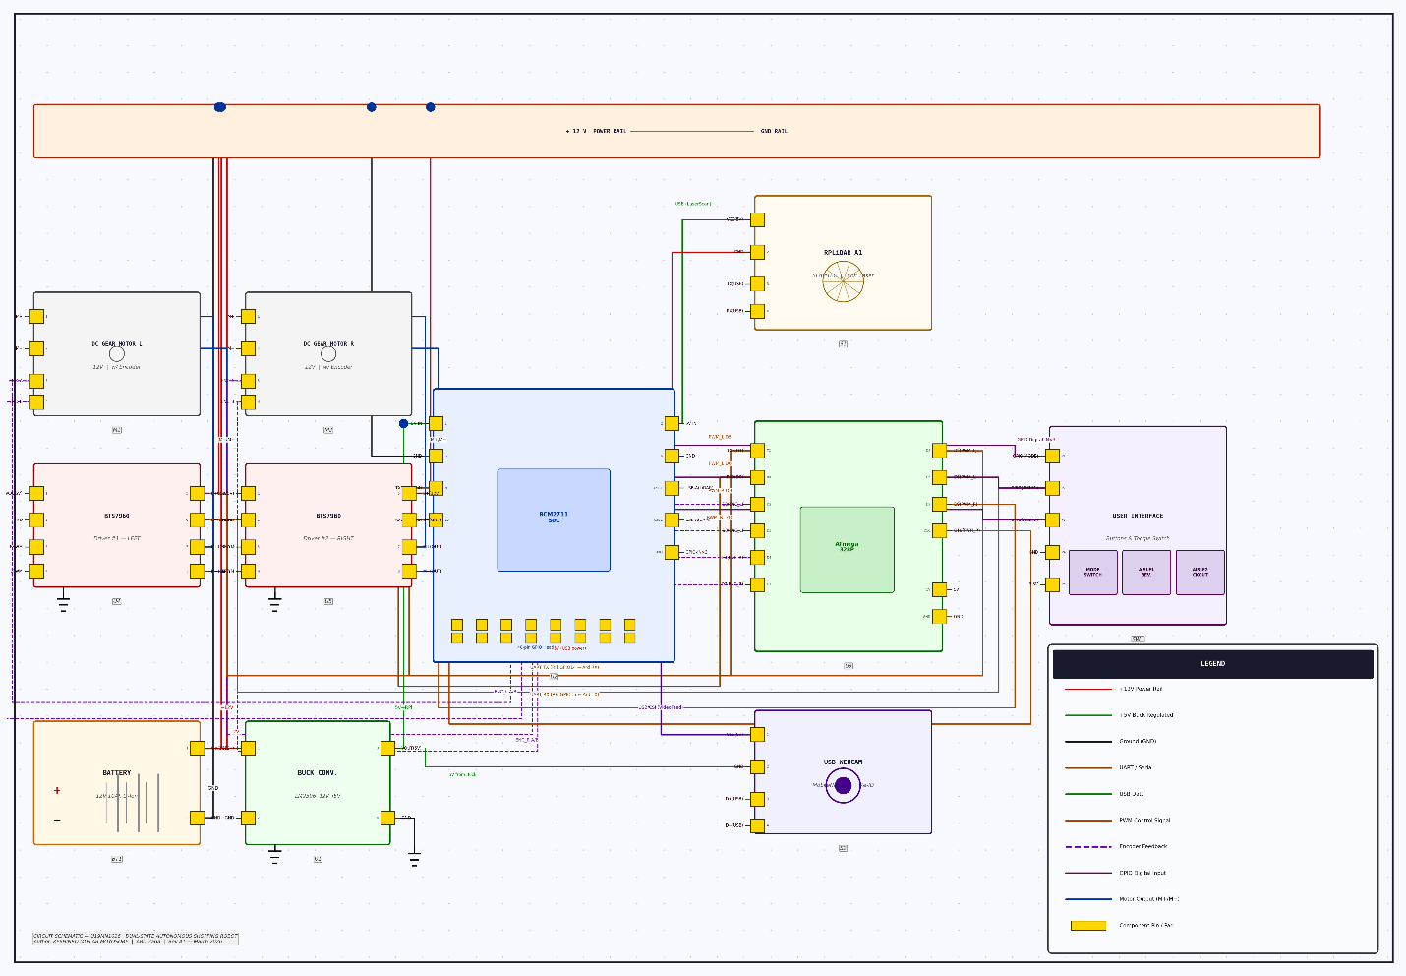
Figure 3.3 Circuit Diagram

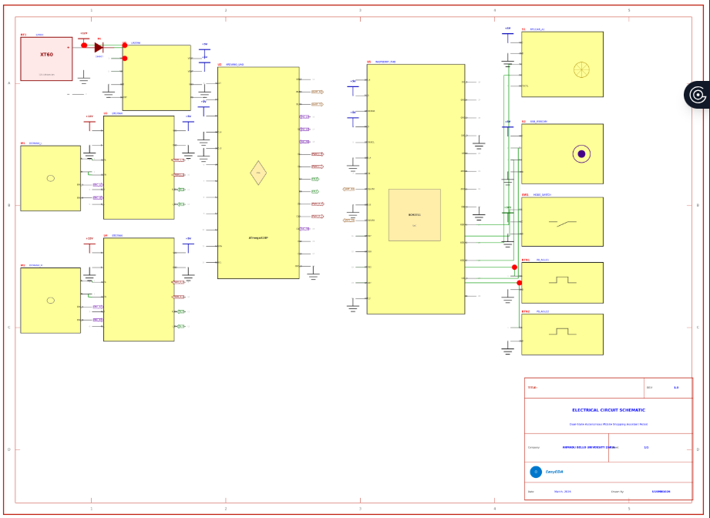
Figure 3.4 Schematic Diagram

4 TIMELINE
To ensure the systematic and timely completion of the prototype, the project execution is strategically divided across a 12-week (3-month) schedule, delineated in the Gantt chart format below.

4.1 GANTT CHART
Activity / Project Phase | Week 1 | Week 2 | Week 3 | Week 4 | Week 5 | Week 6 | Week 7 | Week 8 | Week 9 | Week 10 | Week 11 | Week 12
Literature Review & Proposal Defense
Component Procurement & Contingency Planning
Mechanical Chassis Assembly & Wiring
ROS 2 Setup & LiDAR SLAM Configuration
Vision Tracking (MobileNet-SSD) Integration
State Machine Logic & Return-to-Home Coding
System Testing, Tuning, & Obstacle Evaluation
Final Documentation & Project Presentation

5. EXPECTED OUTCOMES AND CONTRIBUTIONS

5.1 ANTICIPATED RESULTS AND FINDINGS
- A Smart, Reliable Shopping Companion: A fully functional mobile robot that works in two modes: following a shopper and navigating the store independently.
- Even if someone walks in between the robot and the shopper, it’s designed to keep a lock on its target over 90% of the time.
- Using LiDAR and ROS 2, the robot builds its own digital map of the store. It can dodge moving obstacles in real-time and find its way from point A to point B without lag.
- Once a task is done, the robot is smart enough to drive itself back to a starting station; no human or remote control required.

POTENTIAL CONTRIBUTIONS TO THE FIELD
- A Unified "Follow-then-Navigate" Framework: Most service robots are built for a single task. This research contributes a practical method for switching between passive human-following and active goal-oriented navigation, making robots more versatile for real-world retail environments.
- Solving "Visual Occlusion" in Crowded Spaces: This work offers a solution to a common industry headache: robots losing their "target" in a crowd. It provides a more robust way for machines to keep track of humans in dynamic, unpredictable settings.

6 RESOURCES AND BUDGET

6.1 LIST OF REQUIRED RESOURCES

6.1.1 Hardware Components
Primary Component | Description/Role | Strategic Alternative
Raspberry Pi 4B (4GB/8GB) | The "Brain": Handles ROS 2, Navigation, and AI processing. | Jetson Nano (Better for AI) or Orange Pi 5 (Cheaper high-perf alternative).
2D LiDAR (RPLiDAR A1/A2) | For SLAM and 360° obstacle detection. | Ultrasonic Sensor Array (Much cheaper, but less accurate for mapping).
Raspberry Pi Camera (v2) | Used for the MobileNet-SSD human-following logic. | USB Webcam (Logitech C270) (Easier to mount/cheaper).
Differential Drive Chassis | Includes 2x High-torque DC Motors + Encoders. | Custom MDF/Acrylic Chassis with geared yellow motors (for tight budgets).
L298N or L293D Motor Driver | Interfaces the Pi/Microcontroller with the motors. | BTS7960 43A Driver (If using heavy-duty motors).
Arduino Uno or ESP32 | Handles low-level motor PWM and encoder counts. | STM32 Blue Pill (Industry standard) or RP2040.
Li-ion Battery Pack (12V) | Powers the motors and the Raspberry Pi. | Lead Acid Battery (Heavier, but widely available in local markets).

6.1.2 Software Components
Tool / Service | Application | Alternative
ROS 2 (Humble/Foxy) | The middleware for node communication and Nav2. | Micro-ROS (For resource-constrained setups).
Ubuntu 22.04 LTS | The OS for the Raspberry Pi. | Debian/Raspberry Pi OS (Though ROS support is best on Ubuntu).
TensorFlow Lite / Keras | For running the MobileNet-SSD tracking model. | OpenCV (Haar Cascades) (Lower accuracy but lighter on CPU).
Rviz2 & Gazebo | For 3D visualization and physics simulation. | Webots (Lighter simulation alternative).
Python 3.x | Primary language for AI and high-level logic. | C++ (For better performance in ROS nodes).

6.1.3 Others
- Workstation/Laptop: Minimum 8GB RAM (16GB preferred) for running Gazebo simulations and Rviz.
- Local Network (Router): For SSH access and ROS_DOMAIN_ID communication between your laptop and the robot.
- Power Buck Converter (LM2596): To step down 12V battery power to 5V for the Raspberry Pi.
- Calibration Markers: High-contrast floor markings for testing "Return-to-Home" accuracy.

ESTIMATED BUDGET
The budget prominently features the primary 2D LiDAR sensor required for robust mapping, while simultaneously noting the contingency alternative (RGB-D Depth Camera) should extreme budget constraints or supply chain issues mandate a hardware pivot. The estimated costs are derived from prevailing market research in Nigeria (Naira) for the 2025/2026 academic period.
S/N | Item | Qty | Unit Price (₦) | Total (₦)
1. | Raspberry Pi 4 Model B (4GB RAM) | 1 | 130,000 | 130,000
2. | SLAMTEC RPLidar A1 | 1 | 120,000 | 120,000
3. | 12V High-Torque DC Gear Motor w/Encoder | 2 | 25,000 | 50,000
4. | BTS7960 43A High- Power Motor Driver | 2 | 12,000 | 24,000
5. | 12V 10Ah Lithium-Ion Battery Pack | 1
6. | Standard USB Webcam | 1 | 15,000 | 15,000
7. | Differential Drive Chasis Base & Wheels | 1 | 50,000 | 50,000
8. | Power Buck Converter (12V to 5V) | 1 | 10,000 | 10,000
9. | Push Buttons, Switches & Basic UI | 1 set | 10,000 | 10,000
10. | Miscellaneous (Jumpers, Screws) | 1set | 10,000 | 10,000
11.
12. | Xbox Kinect | 1 | 15,000 | 15,000
13. | Standard DC TT Motors w/Encoders | 2 | 25,000 | 50,000
14. | L298N Motor Driver | 2 | 7000 | 14,000
15. | 12V 7Ah Lead Acid Battery | 1 | 27,000 | 27,000
16. | Custom DIY Acrylic/MDF Chasis | 1 | 20,000 | 20,000
17.
 | Total Estimated Cost |  | 419,000

7. CONCLUSION
This project comprehensively proposes the design and implementation of a dual-state, autonomous mobile shopping assistant robot tailored to alleviate the physical and navigational burdens inherent in modern supermarket environments. By synergistically integrating advanced deep learning vision algorithms (MobileNet-SSD or YOLO and Re-ID) for robust human following, alongside the powerful ROS 2 Nav2 stack and 2D LiDAR for dynamic point-to-point guidance and autonomous return-to-home capabilities, the system offers a highly sophisticated, end-to-end automated retail solution optimized for student-level hardware.

8. REFERENCES
Carlos, J., Jee Won Kim, T.L, P., Pontes, N., & Sven Tuzovic. (2023). Retail robots as sales assistants: how speciesism moderates the effect of robot intelligence on customer perceptions and behaviour. Journal of Service Theory and Practice, 34(1), 127–154. https://doi.org/10.1108/jstp-04-2023-0123
Chen, K., Szeto, C., Tran, B., & Wright, L. (n.d.). The Design of Team Inspiration’s 2025 RoboBoat Autonomous Surface Vehicle. Retrieved March 6, 2026, from https://robonation.org/app/uploads/sites/3/2025/02/TDR_TeamInspiration_RB2025-compressed.pdf
Choi, D., Jashwanth Rao Venepally, & Kim, D. (2025). Path-Planning and Navigation for Robots Considering Human–Robot–Environment Interactions in Supermarket Environments. Electronics, 14(11), 2111–2111. https://doi.org/10.3390/electronics14112111
De Simone, G., Foggia, P., & Vento, M. (n.d.). Autonomous mobile robot for automatic out of stock detection in a supermarket. https://openaccess.thecvf.com/content/ICCV2023W/ACVR/papers/De_Simone_Autonomous_Mobile_Robot_for_Automatic_out_of_Stock_Detection_in_ICCVW_2023_paper.pdf
Keith, R., & La, H. M. (2024). Review of Autonomous Mobile Robots for the Warehouse Environment. ArXiv (Cornell University). https://doi.org/10.48550/arxiv.2406.08333
Macenski, S., & Jambrecic, I. (2021). SLAM Toolbox: SLAM for the dynamic world. Journal of Open Source Software, 6(61), 2783. https://doi.org/10.21105/joss.02783
MITTAL, R., KHANDELWAL, D., NEMADE, K. H., RANI, G., DHAKA, V. S., PATHAK, V., & LATHAR, P. (2026). IEEE Xplore Full-Text PDF: Ieee.org. https://ieeexplore.ieee.org/iel8/6287639/10820123/11222108.pdf
Odland, T. (2025). Sonair | Journal | Comparing sensor technologies for mobile robot safety: LiDAR, cameras, ultrasonics. Sonair.com. https://www.sonair.com/journal/comparing-sensor-technologies
Oitzman, M. (2022, April 5). Geek+ delivers AMR cross-docking solution to supermarket operators worldwide - Automated Warehouse. Automated Warehouse. https://www.automatedwarehouseonline.com/geek-delivers-amr-cross-docking-solution-to-supermarket-operators-worldwide/
Renno, R. (2024). Retail Robotics Are Here to Transform the Industry: from Warehouse to Delivery | Jabil. Jabil.com. https://jabil.com/blog/autonomous-retail-robots.html
Rollo, F., Zunino, A., Raiola, G., Amadio, F., Ajoudani, A., & Tsagarakis, N. (2023). FollowMe: a Robust Person Following Framework Based on Visual Re-Identification and Gestures. 2023 IEEE International Conference on Advanced Robotics and Its Social Impacts (ARSO), 84–89. https://doi.org/10.1109/arso56563.2023.10187536
Shashikant Kalsha. (2025). Autonomous Retail: AI and Robotics in Checkout-Free Stores | QodeQuay. Qodequay.com. https://www.qodequay.com/autonomous-retail-ai-robotics
Staff, R. 24/7. (2022, April 4). Geek+ Offers Supermarket Operators Cross-Docking Terminal for Mobile Robots. Robotics 24/7. https://www.robotics247.com/article/geek_offers_supermarket_operators_cross_docking_terminal_for_mobile_robots
Wei, Z., Wang, S., Chen, K., & Wang, F. (2025). ROS-Based Navigation and Obstacle Avoidance: A Study of Architectures, Methods, and Trends. Sensors, 25(14), 4306–4306. https://doi.org/10.3390/s25144306
Welcome To Zscaler Directory Authentication. (2026). Strategicmarketresearch.com. https://www.strategicmarketresearch.com/market-report/retail-robotics-market
Younes, Y. A., & Barczyk, M. (2021). Optimal Motion Planning in GPS-Denied Environments Using Nonlinear Model Predictive Horizon. Sensors, 21(16), 5547. https://doi.org/10.3390/s21165547

